Sid-Ali Abdullahi

CS 163 HW 2 WRITTEN HOMEWORK QUESTIONS

1/26/2015

1. **Recursion.** In our textbook on recursion it talks about using the box trace to systematically trace the actions of a recursive function. Box tracing can be used to help understand recursion and to assist in debugging such recursive functions.

**Take one of the recursive functions** written for Lab #1 and use the box trace method to illustrate the function. Start with a piece of paper with your code printed on it. Label each recursive call. Draw an arrow from the statement that initiates the recursive process to the first box. Then, when you create a new box after a recursive call, draw an arrow from the box that makes the call to the newly created box. Label each. On exiting the function, cross off the current box and follow its arrow back to the box that called the function. Turn in a .pdf or .jpg of the page.

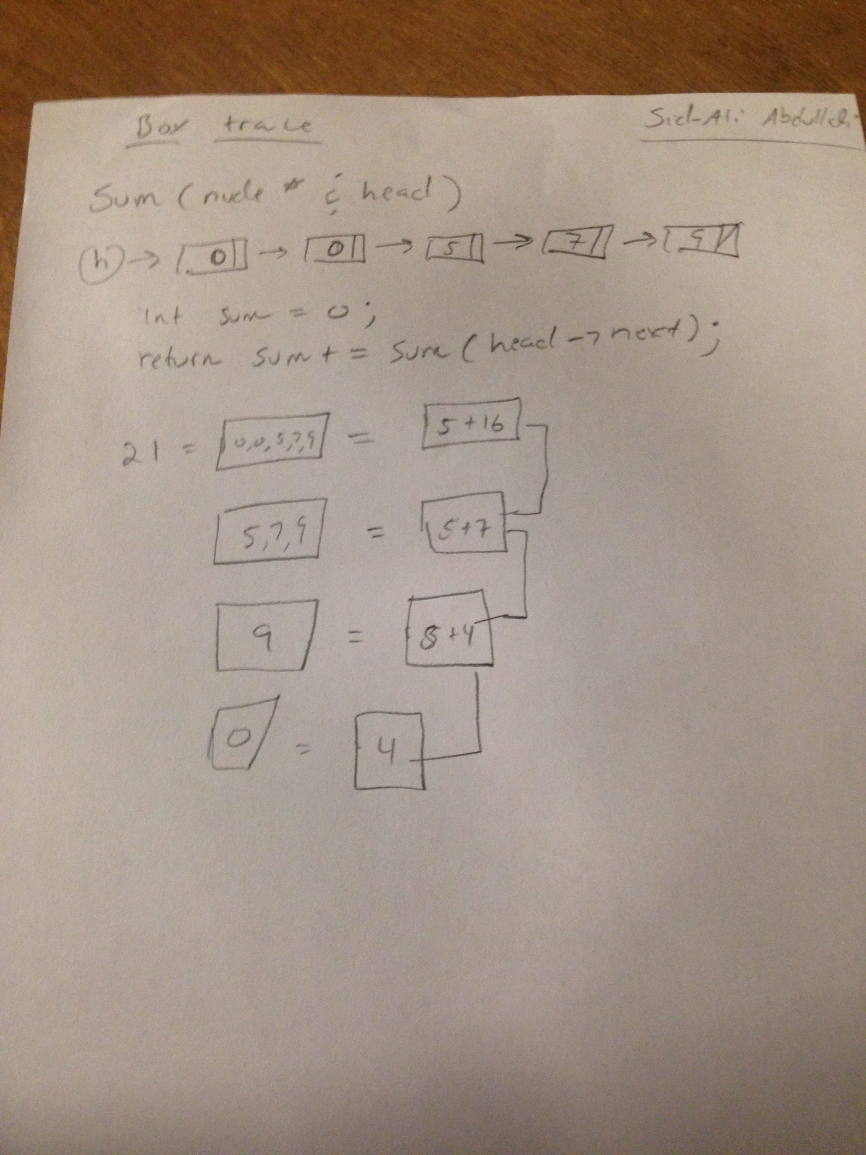

2. **Ethics.** Write a paragraph exhibiting an example of the misuse of computers in business; it needs to be a true story written in your own words. Discuss why the example demonstrates issues computer ethics and what we can do as a society to minimize these types of situations occurring.

I personally have never witnessed an act of unethical practice pertaining to computers and the business world but have watched plenty of shows about thus exact encounter on television. One show I particularly like to watch is American Greed. This show features individual who have been engaged in some activates which could be deemed as unethical and made some misjudgments correlating to financial merits. One particular episode showcased an employee who worked in a the financial industry and obtained credit card numbers from clients through hacking the company database, then constructing credit cards with those account numbers and then distributed the cards to a network of people. This is a prime example of ethics and the computer business, maybe a little it extreme though.

3. **Algorithm.** Write an algorithm to determine if a linked list is linear or circular.

An algorithm to determine if a list is either circular or linear, from my understanding would be that a circular list would never have a null pointer as where a linear linked list would have a null pointer once traversed through the list. I would traverse the list with a while loop and if the loop terminates with a while(current) condition, then I would assume the list is linear since the null pointer has been reached at the end of the list, otherwise if the loop continues to execute without termination, I would conclude a circular list is present.

4. **Experiencing Linux.** As we begin writing programs with more .cpp and .h files, makefiles become more important. Research what a makefile is and why it might be used. Try writing a simple makefile on linux and experiment with it. *Write a paragraph about your findings.*

When I used makefile to I discovered the syntax to be a little confusing at first, but when I reread the instructions and the documentation of the utility, I found out it makes compiling a host of cpp files a lot easier to do with the shortcut functionalities that make file provides. For instance compiling with a flag for the warning –Wall shortcut makes compiling with errors easier to do with mapping the –Wall to to compiling your program.